Parliamentary Speech Analysis of the Turkish Grand
National Assembly (TBMM)
28th Legislative Term (2023-2026) | STAT 401 Big Data Final Project | June 2026
Başak Uğurlu 2561546 | Zeynep Fenercioğlu 2561264 | Damla Başarmış 2510048

1. Introduction
This project turns official plenary minutes of the Turkish Grand National Assembly (TBMM) into a structured speech-level dataset and uses it to examine parliamentary activity during the 28th legislative term. TBMM transcripts are rich but highly unstructured political text sources. By collecting the raw minutes, parsing them into individual speeches, enriching speakers with party and province information, and analyzing them with big data tools, the project makes parliamentary discourse measurable at scale.
The research questions are: (1) How do parties differ in speech volume, total word output, and average speech length? (2) Which MPs and provinces dominate parliamentary floor activity? (3) Which words and policy themes are most characteristic of each party and province? (4) How does activity change across legislative years and calendar months?

2. Data Collection
The raw data source is the official TBMM plenary transcript website, specifically the Tutanak Metinleri page. The broad raw collection stage covers the 23rd-28th terms and stores one row per parliamentary session, so every row corresponds to one birleşim and keeps the full raw transcript text before any speaker-level parsing. Each record includes session_id, term, legislative year, session number, date, source URLs, raw transcript text, raw_text_length, scrape_status, and error_message. The downstream analysis in this report uses the verified 28th-term subset.
Python, requests, BeautifulSoup, pandas, and pyarrow were used. The notebook includes Google Colab and Google Drive persistence so that results can be saved incrementally while scraping. Requests are single-threaded and include a descriptive user agent, controlled delay, timeout handling, retries, and backoff. A session_id-based deduplication mechanism skips sessions that were already saved. No paid proxies, rotating IP addresses, or CAPTCHA-bypass tools were used.
Dataset stage | Size | Main output / role
Raw 28th-term sessions | 342 sessions, all OK | raw_tutanaklar_28_clean.csv / .jsonl / .parquet
Speaker-level parsed table | 199,158 speech rows; 2,103 raw speakers | tutanaklar_28_konusmaci_bazli.csv
MP party-city lookup | 599 MPs | milletvekili_party_city_lookup.csv
Final analysis table | 196,442 rows x 18 columns | donem28_konusmaci_bazli.csv

3. Data Preprocessing
Preprocessing was the largest technical stage of the project. First, the 28th-term raw session table was converted into a speech-level table using a regex-based parser. The parser detects speaker openings such as MP names with provinces, chair interventions beginning with BASKAN, group speeches, and continuation labels such as Devamla. It also removes session headings, table-of-contents lines, opening/closing metadata, and procedural separators. Each extracted record receives a speech order, character length, and word count.
Second, party and province information was enriched. Since many continuation speeches and institutional speaker lines do not contain complete province or party information, a separate lookup table was built from the TBMM MP e-mail directory. The lookup uses normalized name keys, party standardization, Turkish character handling, city aliases, and a manual patch for MPs who left office during the 28th term. This lookup is then merged back into the parsed speech table.
Finally, the final-table notebook repairs common encoding problems, standardizes party labels, classifies speaker types, preserves source URLs, and keeps province fields empty for institutional roles where province is not meaningful, such as chair, minister, president, or committee roles. Rows with unresolved MP party information and parse errors are excluded from the analysis-ready file, producing a clean final dataset of 196,442 rows and 18 columns.

4. Methodology
The main analysis was conducted with Apache Spark 4.0.2 through PySpark. Spark was used because the project handles large text records and repeated aggregations over hundreds of thousands of speech rows. The analysis notebook reads the final CSV with multiline text support, filters MP speeches when party-level interpretation is needed, standardizes party names, and uses Spark DataFrame operations such as groupBy, count, sum, avg, when, orderBy, lower, regexp_replace, split, and explode.
The analysis combines descriptive big data aggregation with text mining. Party and MP activity are measured by speech count, total words, and average words per speech. Word-frequency analysis uses Turkish-aware cleaning and a custom stop-word list that removes grammatical particles, parliamentary protocol words, and transcript artifacts. Province-level word frequencies are normalized per 10,000 words to avoid giving automatic advantage to large provinces. Topic analysis uses keyword-based filtering for five themes: economy, education, health, agriculture, and earthquake. Monthly and legislative-year trends are created with date-based aggregation.

5. Results
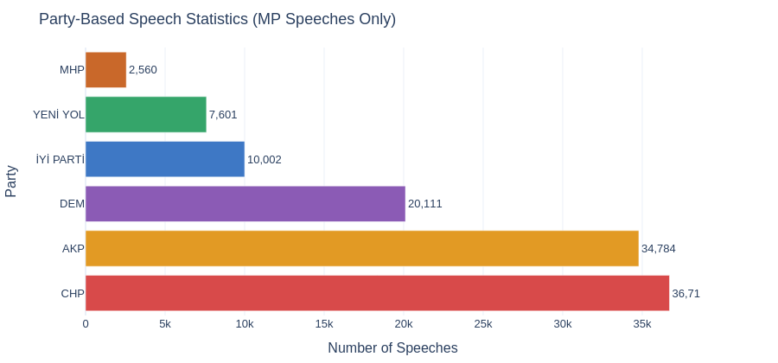

At the party level, CHP has the highest number of MP speeches with 36,711 speeches and 2,225,464 total words. AKP follows closely in number of speeches with 34,784, but its average speech length is lower at 42.1 words. DEM, İYİ Parti, Yeni Yol, and MHP have fewer speeches, but several of them have longer average speech lengths, suggesting more extended interventions rather than short procedural turns.
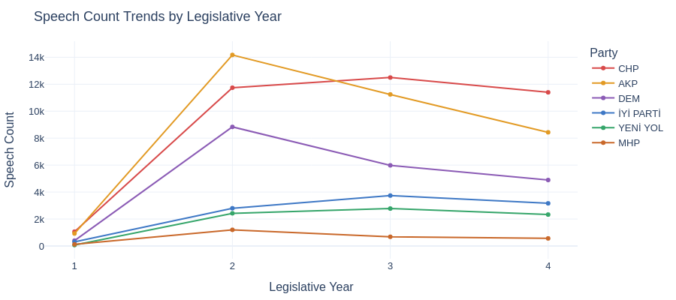

Legislative-year trends show that the second legislative year is the most active period in terms of speech counts, while the third year remains close in total word output. The fourth year should be interpreted carefully because it was still incomplete at the time of collection. The trend charts also show a shift in party leadership: AKP has the highest speech count in year 2, while CHP leads in later years.

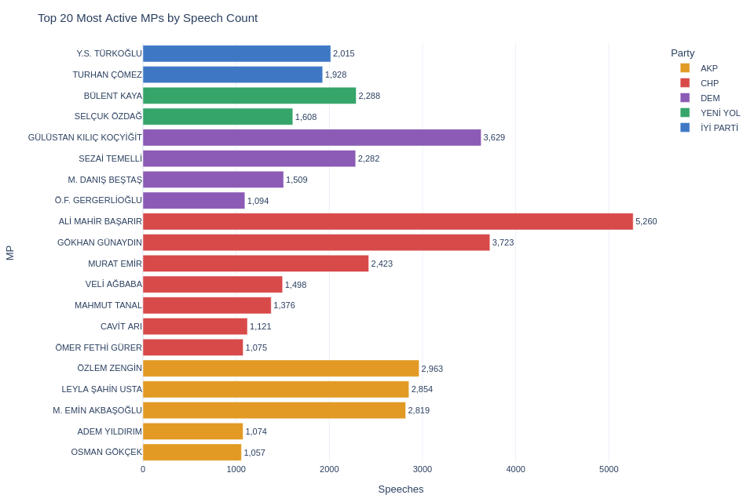
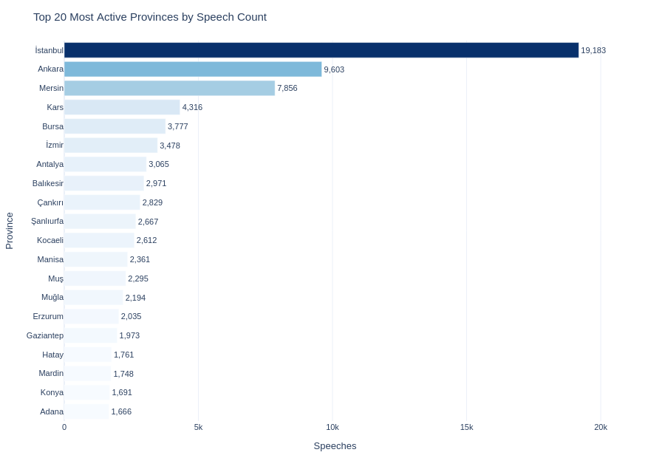

The most active individual MPs are Ali Mahir Başarır, Gökhan Günaydın, and Gülistan Kılıç Koçyiğit. Province-level results show Istanbul, Ankara, and Mersin at the top in total activity, but Kars ranks unusually high because one very active MP contributes a large number of speeches and words. This shows why both province totals and individual-MP concentration must be interpreted together.

After stop-word removal, parties display different rhetorical profiles. CHP vocabulary is strongly connected with socioeconomic and administrative issues such as health, retirees, municipality, minimum wage, tax, and agriculture. DEM Party discourse highlights identity, democratic rights, peace, women, and trustee-related vocabulary. MHP is characterized by nationalist vocabulary such as Turkish, national, movement, and nation. Province-normalized results reveal local issues: Hatay is strongly associated with earthquake terms, Van and Diyarbakır with Kurdish identity terms, and Şanlıurfa with local references, electricity, and agriculture.
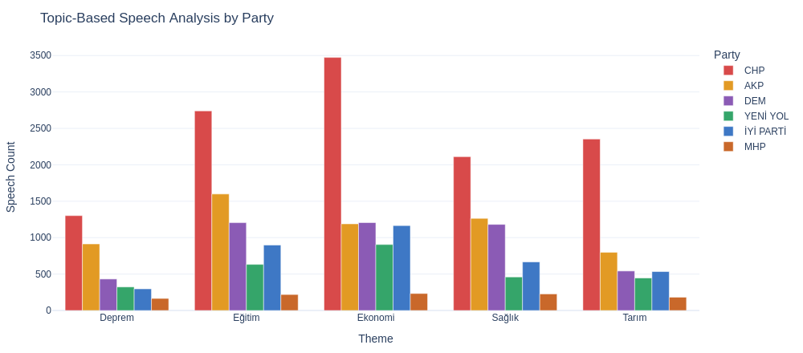

Among the five predefined policy themes, economy is the most frequently discussed theme with 8,443 related speeches, followed by education with 7,450, health with 6,031, agriculture with 4,964, and earthquake with 3,504. CHP leads all five themes, indicating strong use of parliamentary speech for opposition oversight and issue framing. The most active speakers differ by theme, with Ali Mahir Başarır leading economy and education, Turhan Çömez leading health and agriculture, and Necmettin Çalışkan leading earthquake-related speeches.
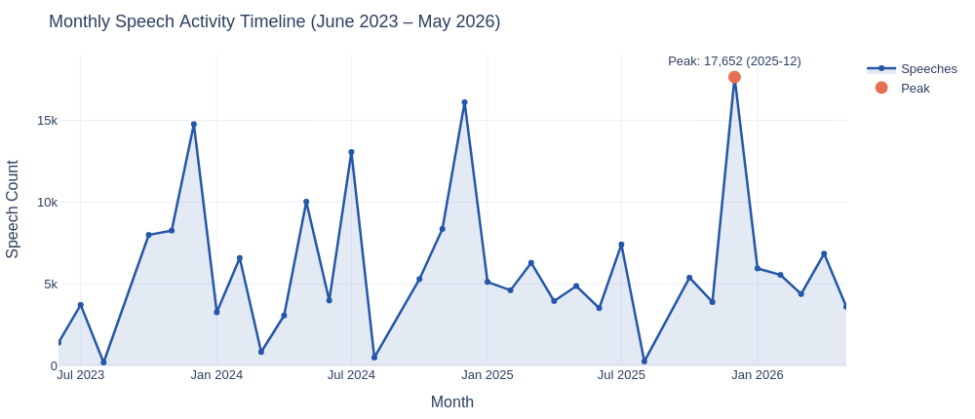

Monthly activity has a clear seasonal pattern. December is consistently the peak month, most likely due to annual budget deliberations. August and September are almost inactive because of parliamentary recess. The busiest single month in the dataset is December 2025 with 17,652 speeches, and 2024 has the highest cumulative annual speech count with 71,004 speeches.

6. Dashboard
The interactive dashboard was built using Streamlit and Plotly (interactive_tbmm_dashboard.py) and mirrors the structure of the static PDF output. It contains nine tabs covering the full analysis pipeline: dataset overview, party-level speech statistics, legislative-year trends, the top 20 most active MPs, the top 20 most active provinces, party keyword profiles, normalized province keyword analysis, topic-based speech counts, and the monthly activity timeline. All charts are interactive, supporting hover, filtering by party, province, or theme, and dynamic rescaling. The charts embedded above are static exports of the same visualizations.
Users can navigate from high-level summary tabs to detailed analytical views. Bar charts are used for ranked comparisons, line charts for temporal trends, scatter plots for bivariate relationships, and compact data tables for exact values alongside the visuals.

7. Conclusion
The project created an original, analysis-ready dataset from official TBMM plenary transcripts and transformed unstructured political text into a structured table of 196,442 speech records. The main findings are that CHP is the most active party by speech and word output, AKP has many shorter interventions, DEM Party has a distinct rights- and identity-focused vocabulary, and the strongest thematic areas are economy, education, and health. Monthly activity confirms the importance of December budget sessions and the low activity of recess months.
Possible improvements include extending speech-level parsing to the earlier 23rd-27th terms, using unsupervised topic modeling such as LDA, NMF, or BERTopic, applying sentiment or stance analysis, adding named-entity recognition, and turning the PDF dashboard into a fully interactive dashboard with filters for party, province, speaker, date, and theme.

8. References
- TBMM Plenary Transcripts. https://tbmm.gov.tr/Tutanaklar/Tutanak-Sorgu-Sonuclari
- TBMM MP Directory. https://tbmm.gov.tr/milletvekili-arama/form

9. Team Contribution
Başak Uğurlu contributed mainly to data collection and preprocessing, including the TBMM scraping workflow, raw session table, speaker-level parsing, MP party-city lookup table, and final analysis-ready dataset. Zeynep Fenercioğlu and Damla Başarmış contributed mainly to PySpark analysis, interpretation of results, dashboard design, and visualization. The final report and presentation were reviewed as a group to connect the collection, preprocessing, analysis, and dashboard stages into one coherent project.

